CODE IMPLEMENTATION FILE
On

ENERGY HARVESTING SYSTEM USING PIEZO TILES

BACHELOR OF ENGINEERING
In
COMPUTER SCIENCE AND ENGINEERING (IoT with
Cyber Security Including Blockchain Technology)
By
RIDHIMA BALAKRISHNA GADALAY (160123749018)
MANPREET KOUR (160123749013)
HARINI PORUMAMILLA(160123749015)
SUHAAS.B (160123749026)
ASHWITH REDDY (160123749060)

Under the Supervision of
N. Sujata Gupta
Assistant Professor
Department of Computer Engineering and Technology
Chaitanya Bharathi Institute of Technology (Autonomous)
(Affiliated to Osmania University) Hyderabad, TELANGANA (INDIA)–500 075
[2025-2026]

IMPLEMENTATION
The IoT-Based Human Energy Harvesting System integrates hardware, power management, and IoT components to form a functional prototype. Each subsystem was tested individually before full integration.
The hardware implementation involved two energy sources. Piezoelectric discs embedded under a wooden or plastic platform generated AC when pressure was applied through footsteps, which was then rectified to DC. A 12V DC motor with a hand crank acted as a kinetic energy generator, producing AC that was rectified and fed into a shared energy buffer. The harvested energy was stored in a supercapacitor or Li-ion battery, with Schottky diodes preventing reverse flow and a boost converter regulating a stable 3.3V output. An ESP32 microcontroller interfaced with an INA219 sensor to monitor energy, while an LCD display provided on-device feedback.
The ESP32 firmware was programmed to remain in deep sleep and wake when buffer voltage exceeded a threshold. It collected voltage, current, and power data, transmitting it wirelessly to IoT dashboards such as Blynk or ThingsBoard for real-time monitoring. The LCD display and cloud dashboards enabled users to track their energy contributions over time.
The integrated system was tested for rectification, energy storage, voltage regulation, and IoT data transmission. The end-to-end demonstration confirmed that footsteps and crank rotations could power the ESP32 and update live data. The prototype successfully harvested human mechanical energy, powered devices, and enabled real-time monitoring, demonstrating the feasibility of converting daily human activity into usable electricity for educational and practical applications.
1.1 Arduino IDE Setup
1. Introduction
The Arduino Integrated Development Environment (IDE) is the primary software used for writing, compiling, and uploading code to microcontroller boards such as the ESP32, Arduino Uno, Nano, and other compatible devices. It provides a user-friendly platform that simplifies programming, debugging, and communication with embedded systems. For this project, the Arduino IDE was used to write and upload the control program to the ESP32 microcontroller, which manages data acquisition, processing, and IoT communication.
2. Software Installation
To begin the setup, the Arduino IDE must first be installed on the computer. It can be downloaded from the official Arduino website (https://www.arduino.cc/en/software). After installation, the IDE provides all necessary tools, including:
- A text editor for writing the source code (sketches).
- A compiler for converting the written code into machine language.
- An uploader for transferring the compiled program to the connected microcontroller board.
3. Configuring the ESP32 Board in Arduino IDE
Since the ESP32 is not included by default in the Arduino IDE board list, an additional setup process is required:
- Open the IDE and go to:
File → Preferences
- In the “Additional Boards Manager URLs” field, add the following URL:
- https://dl.espressif.com/dl/package_esp32_index.json
- Next, navigate to:
Tools → Board → Boards Manager
- Search for ESP32 and click Install on the “esp32 by Espressif Systems” package.
- Once installation is complete, select the correct board by going to:
Tools → Board → ESP32 Dev Module.
This process allows the Arduino IDE to recognize and communicate with the ESP32 board.
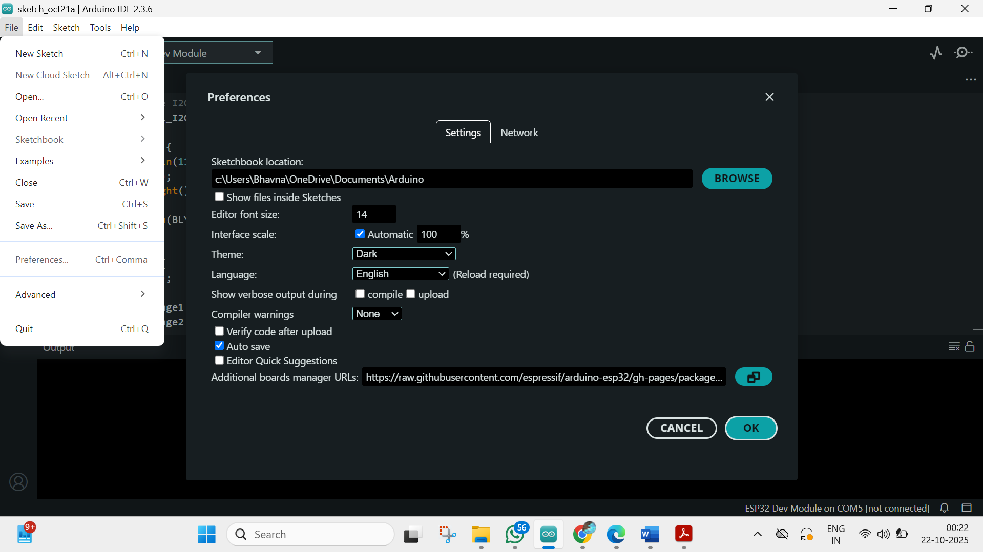
Fig., 1 Fig., 2
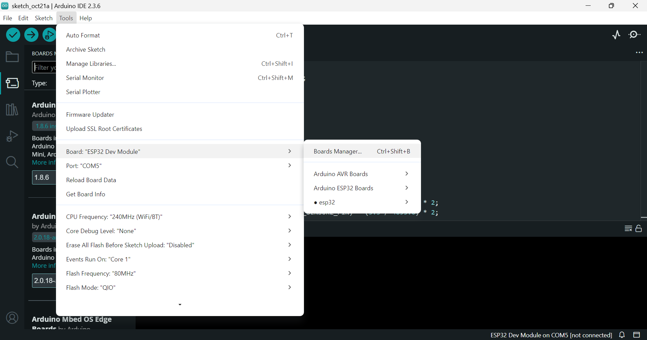
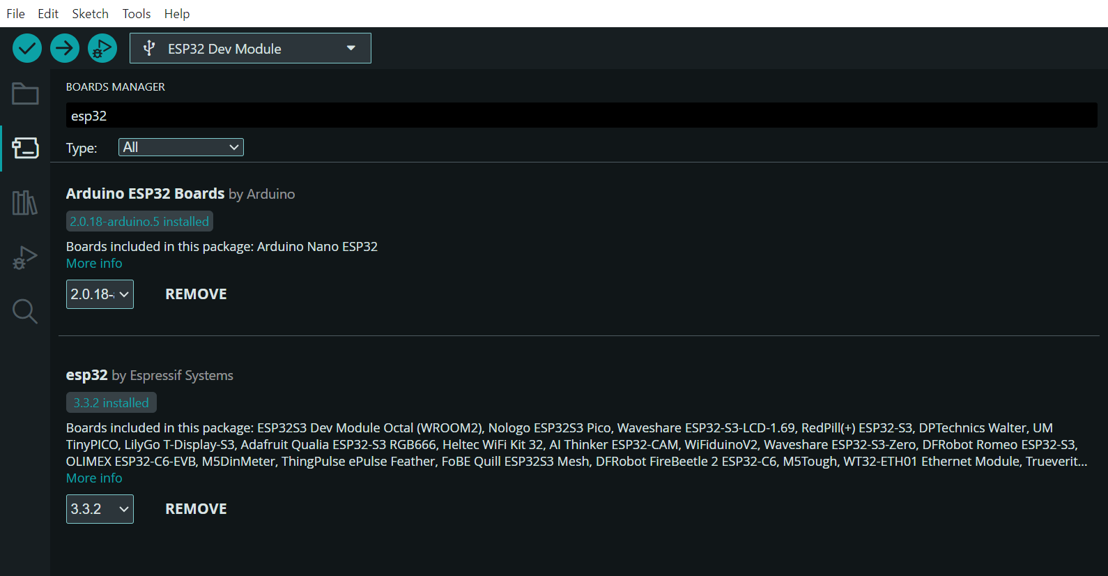
Fig., 3
4. Selecting the Communication Port
After connecting the ESP32 to the computer via USB cable, the IDE automatically detects the available communication port.
To configure it:
- Go to Tools → Port and select the port labeled as “COMx (ESP32 Dev Module)” (where x represents the port number).
This step ensures proper communication between the computer and the ESP32 for program uploading and serial monitoring.
1.2 Driver Installation for ESP32 / Arduino Board
1. Introduction
Before uploading code from the Arduino IDE to a microcontroller board such as the ESP32 or Arduino UNO, the computer must recognize the device through a proper USB-to-Serial driver. This driver enables communication between the board and the computer via the USB port. Without it, the system will fail to detect the connected board, and the COM port will not appear in the Arduino IDE.
The installation process may vary slightly depending on the type of USB chip used in the development board (CH340, CP2102, or FTDI). The following section explains the complete procedure for downloading and installing the required driver.
2. Identifying the USB-to-Serial Chip
Different ESP32 and Arduino boards use different USB interface chips. The most common are:
- CH340 / CH341 – used in many low-cost ESP32 and Arduino clones.
- CP2102 – used in most ESP32 DevKit V1 boards.
- FTDI FT232 – used in some older or premium Arduino models.
To identify which one your board uses:
- Check the marking on the USB chip on the board itself (usually near the USB port).
- Or, refer to the board’s datasheet or manufacturer website.
Once identified, download the corresponding driver.
1.3. CP2101 Driver Download and Installation Process
1. Introduction
The CP2101/CP2102 USB-to-UART Bridge Controller, developed by Silicon Laboratories, is commonly used in ESP32, NodeMCU, and other microcontroller boards to enable serial communication between the computer and the device via a USB cable.
Before the board can communicate with the Arduino IDE, the CP210x Virtual COM Port (VCP) driver must be installed. This driver allows the operating system to recognize the ESP32 board as a serial (COM) port device, making it possible to upload code and monitor serial data.
The following section describes the complete process for downloading and installing the CP2101/CP2102 driver in Windows, macOS, and Linux environments.
- Step-by-Step Procedure for Driver Installation (Windows)
Step 1: Open the Official Silicon Labs Website
- Launch your web browser and visit the official Silicon Labs driver page:
https://www.silabs.com/developers/usb-to-uart-bridge-vcp-drivers
- This page contains the latest CP210x USB to UART Bridge VCP Drivers for various operating systems such as Windows, macOS, and Linux.
Step 2: Download the Windows Driver Package
- Scroll down to the section titled “Downloads” or “CP210x Windows Drivers”.
- Under the Windows category, locate the latest driver version (for example: Windows CP210x VCP Driver (v11.x.x)).
- Click the Download VCP Driver link.
- A compressed ZIP file will be downloaded to your computer (e.g., CP210x_Windows_Drivers.zip).
Step 3: Extract the Downloaded File
- Navigate to your Downloads folder.
- Right-click the downloaded ZIP file and choose “Extract All”.
- Open the extracted folder — it will contain files like:
  - CP210xVCPInstaller_x64.exe (for 64-bit Windows)
  - CP210xVCPInstaller_x86.exe (for 32-bit Windows)

Step 4: Run the Installer
- Double-click on the appropriate installer based on your Windows version:
  - If you are using a 64-bit system → run CP210xVCPInstaller_x64.exe
  - If you are using a 32-bit system → run CP210xVCPInstaller_x86.exe
- A setup window will open. Click Next to begin installation.
- The installer will copy necessary driver files and register the virtual COM port.
- Once completed, a message will appear:
“CP210x USB to UART Bridge Driver successfully installed.”
Step 5: Connect the ESP32 Board
- Connect your ESP32 board (or any device using CP2101) to your computer using a USB cable.
- Windows will automatically detect the new hardware and associate it with the installed CP210x driver.
- Wait a few seconds for the system to configure the COM port.
Step 6: Verify Driver Installation
- Press Windows + X and open Device Manager.
- Expand the section “Ports (COM & LPT)”.
- You should see a device entry such as:
“Silicon Labs CP210x USB to UART Bridge (COMx)”
(where x represents the COM port number)
- Note down this COM port — you’ll use it later in the Arduino IDE under Tools → Port.
If you see this entry, the driver is correctly installed and ready for use.
-Installation on macOS
Step 1: Download the macOS Driver
- Visit the same Silicon Labs link:
https://www.silabs.com/developers/usb-to-uart-bridge-vcp-drivers
- Scroll down to “CP210x macOS Drivers”.
- Click the Download VCP Driver for macOS button.
Step 2: Install the Driver
- Locate the downloaded .dmg file in your Downloads folder.
- Double-click the file and run the Silicon Labs VCP Driver.pkg installer.
- Follow the on-screen instructions and authorize installation if prompted.
- Restart your Mac after installation.
Step 3: Verify Installation
- Open Terminal and type the command:
- ls /dev/tty.*
- You should see a device listed as:
/dev/tty.SLAB_USBtoUART
This indicates that the driver has been installed successfully.
- Installation on Linux
Step 1: Check for Preinstalled Drivers
Most modern Linux distributions (Ubuntu, Debian, Fedora) include CP210x drivers by default.
To check if your system recognizes the device:
- Plug in your ESP32 board.
- Open a terminal and type:
- dmesg | grep tty
- If you see a device listed as /dev/ttyUSB0 or /dev/tty.SLAB_USBtoUART, the driver is already active.
Step 2: Manual Installation (If Required)
If the device is not recognized:
- Download the Linux driver package from Silicon Labs.
- Extract the archive and follow the included README file for building the module.
- Use make and sudo make install commands to install manually.
- Reboot your system and reconnect the board.
2. Troubleshooting Tips
If your computer does not detect the ESP32 board after installation:
- Use a data-capable USB cable (some cables are for charging only).
- Try connecting to a different USB port.
- Reinstall the driver and restart your computer.
- On Windows, ensure that Device Manager shows no yellow warning icon under “Ports”.
- Run the Arduino IDE as Administrator if upload issues persist.
3. Conclusion
The CP2101/CP2102 driver is essential for enabling USB communication between the ESP32 microcontroller and a computer. Installing this driver allows the system to recognize the board as a serial COM device, making it possible to upload code, read serial data, and perform real-time monitoring through the Arduino IDE. A properly installed CP210x driver ensures stable data transmission and reliable performance throughout the project development process.
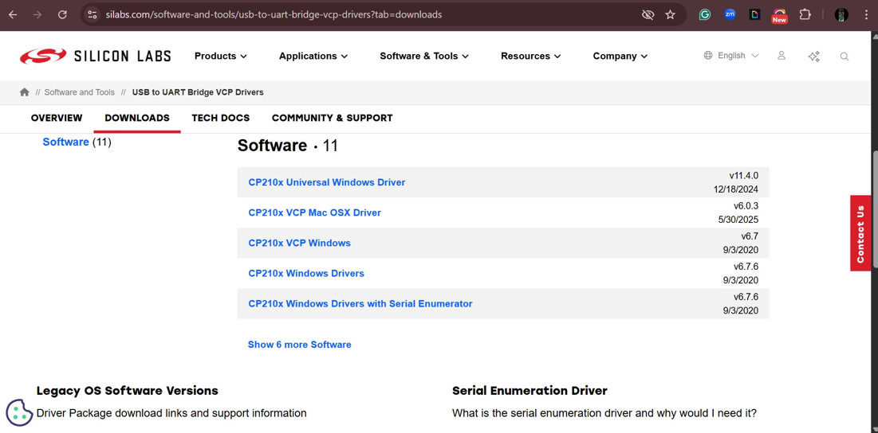
Fig., 4
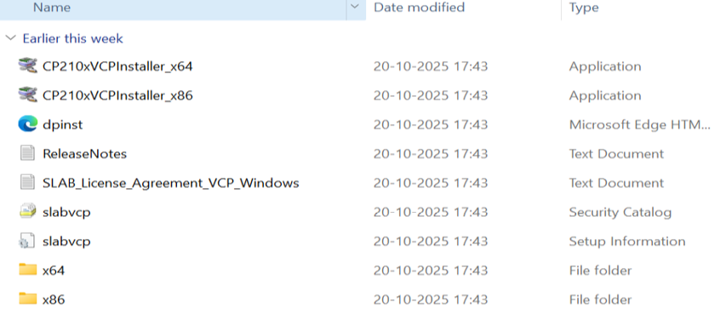
Fig., 5
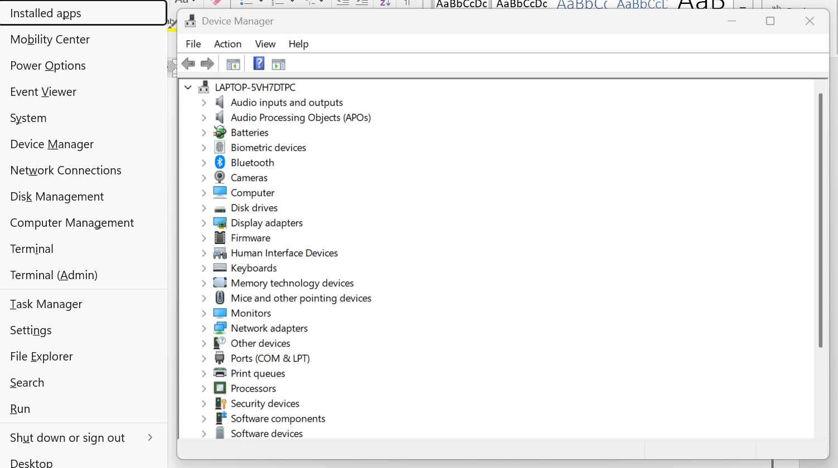
Fig., 6
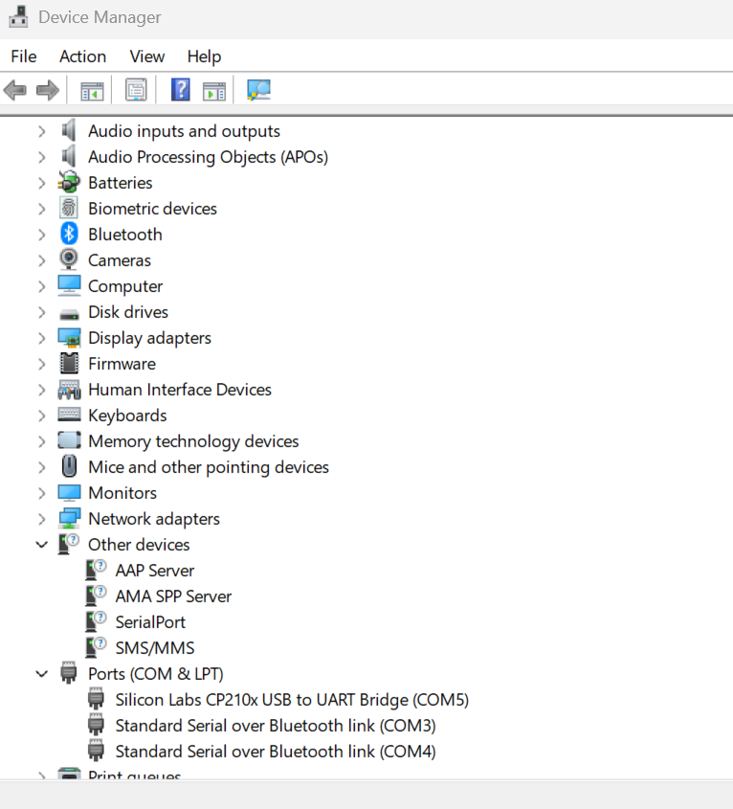
Fig., 7
1.4 code and explanation
#define BLYNK_TEMPLATE_ID "TMPL3q_9oN3uv"
#define BLYNK_TEMPLATE_NAME "Voltagemonitor"
#define BLYNK_AUTH_TOKEN "vee5xtz-06pMvuoWLrT8xVD1UfDskC_p"

#include <Wire.h>
#include <LiquidCrystal_I2C.h>
#include <BlynkSimpleEsp32.h>

// Voltage sensor pins
#define VOLT_SENSOR1_PIN 34
#define VOLT_SENSOR2_PIN 35

// Wi-Fi credentials
char ssid[] = "CMF";
char pass[] = "1234567890";

// Initialize I2C LCD
LiquidCrystal_I2C lcd(0x27, 16, 2);

void setup() {
Serial.begin(115200);
lcd.begin();
lcd.backlight();

Blynk.begin(BLYNK_AUTH_TOKEN, ssid, pass);
}
void loop() {
Blynk.run();

float voltage1 = analogRead(VOLT_SENSOR1_PIN) * (3.3 / 4095.0) * 2;
float voltage2 = analogRead(VOLT_SENSOR2_PIN) * (3.3 / 4095.0) * 2;

lcd.setCursor(0, 0);
lcd.print("V1: ");
lcd.print(voltage1, 2);
lcd.print(" V");

lcd.setCursor(0, 1);
lcd.print("V2: ");
lcd.print(voltage2, 2);
lcd.print(" V");

Blynk.virtualWrite(V1, voltage1);
Blynk.virtualWrite(V2, voltage2);

delay(500);
}
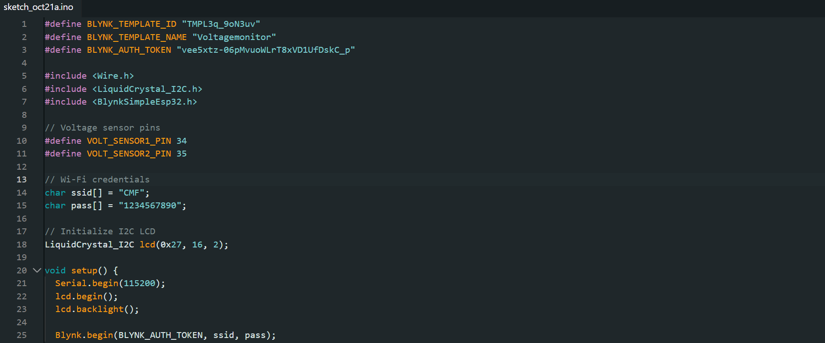
Fig., 8
Code explanation
#define BLYNK_TEMPLATE_ID "TMPL3q_9oN3uv"
#define BLYNK_TEMPLATE_NAME "Voltagemonitor"
#define BLYNK_AUTH_TOKEN "vee5xtz-06pMvuoWLrT8xVD1UfDskC_p"
These three #define macros store constant strings used by the Blynk IoT platform.
- BLYNK_TEMPLATE_ID and BLYNK_TEMPLATE_NAME identify your Blynk template (useful inside the Blynk ecosystem).
- BLYNK_AUTH_TOKEN is the authentication token that lets your device connect to your Blynk project. Do not share this token publicly, anyone with it can write data to your Blynk dashboard.
#include <Wire.h>
#include <LiquidCrystal_I2C.h>
#include <BlynkSimpleEsp32.h>
#include directives pull in external libraries so their functions and classes can be used:
- Wire.h — Arduino's built-in library for I²C communication (used by many I²C displays).
- LiquidCrystal_I2C.h — a library to control an I2C-attached 16×2 LCD easily.
- BlynkSimpleEsp32.h — Blynk library specialized for ESP32 boards; provides Blynk.begin(), Blynk.run(), Blynk.virtualWrite(), etc.
// Voltage sensor pins
#define VOLT_SENSOR2_PIN 35
Two macros define which ESP32 analog input pins read the two voltage sensors:
VOLT_SENSOR1_PIN → GPIO 34
VOLT_SENSOR2_PIN → GPIO 35
On many ESP32 boards these pins are ADC1 channels and are suitable for analogRead. (They are input-only pins.)
// Wi-Fi credentials
char ssid[] = "CMF";
char pass[] = "1234567890";
ssid and pass are C-strings containing the Wi-Fi network name and password that the ESP32 will connect to. These must match an available Wi-Fi access point.
// Initialize I2C LCD
LiquidCrystal_I2C lcd(0x27, 16, 2);
Creates an object lcd of type LiquidCrystal_I2C.
0x27 is the I²C address of the LCD/I²C backpack. If your module uses a different address (e.g., 0x3F) you must change this.
16, 2 tells the library the display size is 16 columns × 2 rows.
void setup() {
Serial.begin(115200);
lcd.begin();
lcd.backlight();
Blynk.begin(BLYNK_AUTH_TOKEN, ssid, pass);
}
setup() runs once at power-up / reset.
Serial.begin(115200); — starts the serial port at 115200 baud for debugging (useful with Serial Monitor).
lcd.begin(); — initializes the LCD display. (Some LiquidCrystal_I2C variants accept parameters here; this call performs the init.)
lcd.backlight(); — switches the LCD backlight on so text is readable.
Blynk.begin(BLYNK_AUTH_TOKEN, ssid, pass); — connects the ESP32 to Wi-Fi and the Blynk cloud using the provided auth token and Wi-Fi credentials. Internally this sets up the network, attempts to connect, and starts Blynk client services.
void loop() {
Blynk.run();
float voltage1 = analogRead(VOLT_SENSOR1_PIN) * (3.3 / 4095.0) * 2;
float voltage2 = analogRead(VOLT_SENSOR2_PIN) * (3.3 / 4095.0) * 2;
loop() runs continuously after setup() finishes.
Blynk.run(); — must be called frequently to keep the Blynk connection alive and handle background tasks (incoming messages, reconnection, timers, etc.).
analogRead(VOLT_SENSOR1_PIN) reads the ADC value from pin 34. On ESP32 the ADC is typically 12-bit, so raw values range from 0–4095 (some cores/variants may differ).
* (3.3 / 4095.0) converts the raw ADC reading to the measured voltage at the ADC pin, assuming a 0–3.3V ADC reference.
* 2 is a voltage-divider correction factor. This implies the sensor input uses a divider (e.g., two equal resistors) that halves the voltage before the ADC. Multiplying by 2 recovers the original input voltage. If your actual divider ratio is different, this factor must be adjusted accordingly.

So the formula is:
voltage = adc_raw * (Vref / ADC_max) * divider_correction
lcd.setCursor(0, 0);
lcd.print("V1: ");
lcd.print(voltage1, 2);
lcd.print(" V");
lcd.setCursor(0, 1);
lcd.print("V2: ");
lcd.print(voltage2, 2);
lcd.print(" V");
These statements display the readings on the 16×2 LCD:
lcd.setCursor(col, row) sets where the next printed text will begin.
lcd.print("...") writes text or numeric values to the display.
voltage1, 2 prints the float with 2 decimal places.
The first line displays V1: <value> V (piezo/hand-crank sensor 1), the second line displays V2: <value> V (sensor 2).
Blynk.virtualWrite(V1, voltage1);
Blynk.virtualWrite(V2, voltage2);
Sends the measured voltages to the Blynk cloud app using virtual pins V1 and V2.
In the Blynk app you should have widgets (gauges, value displays, graphs) configured to read virtual pins V1 and V2.
Note: In this code V1 and V2 are symbolic virtual pin constants provided by Blynk macros. If the compiler complains, you can use V1 as V1 (Blynk defines macros like V1 internally) or use Blynk.virtualWrite(1, voltage1); to explicitly write to virtual pin 1.
delay(500);
}
Pauses execution for 500 ms at the end of each loop iteration.
This sets the update rate to ~2 readings per second.
Caution: delay() blocks execution and will pause anything else in loop() including some time-sensitive Blynk tasks. Because Blynk.run() is called at the start of the loop, short delays like 500 ms are usually acceptable, but long delays (>1s) can affect responsiveness. If you need more responsive networking, replace delay() with a non-blocking timer (e.g., millis() logic) or Blynk timers.
Library Installation process
To execute the ESP32-based energy harvesting project successfully, several libraries must be installed in the Arduino IDE. These libraries enable Wi-Fi communication, IoT connectivity, and LCD display control.
Required Libraries
- Wire – Enables I²C communication between the ESP32 and peripherals (preinstalled).
- LiquidCrystal_I2C – Controls the 16×2 I²C LCD display.
- Blynk – Connects the ESP32 to the Blynk IoT platform for data monitoring.
Installation Steps
- Open the Arduino IDE.
- Navigate to Sketch → Include Library → Manage Libraries…
- In the Library Manager, use the search bar to find and install:
  - LiquidCrystal I2C by Frank de Brabander (or John Rickman).
  - Blynk by Volodymyr Shymanskyy.
- The Wire library is built into the IDE and does not require installation.
- After installation, verify the libraries by checking Sketch → Include Library.
- Restart the Arduino IDE to complete setup.
1.5 Blynk app-IOT integration
Introduction
Blynk is an IoT platform that allows real-time monitoring and control of embedded systems through the internet. In this project, it is used to visualize voltage readings obtained from the ESP32 microcontroller connected to the energy harvesting system. The setup involves creating a template, configuring data streams, and linking the ESP32 board with the Blynk Cloud.
Step-by-Step Setup Process
Step 1: Open Blynk Console
- Visit https://blynk.cloud and sign in with your registered email.
- Once logged in, the Blynk Console Dashboard appears.
- From the left-hand menu, select Developer Zone → Templates.
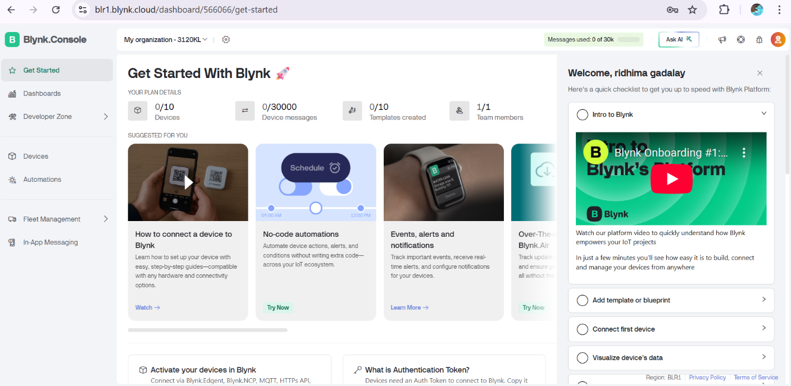
Fig., 9
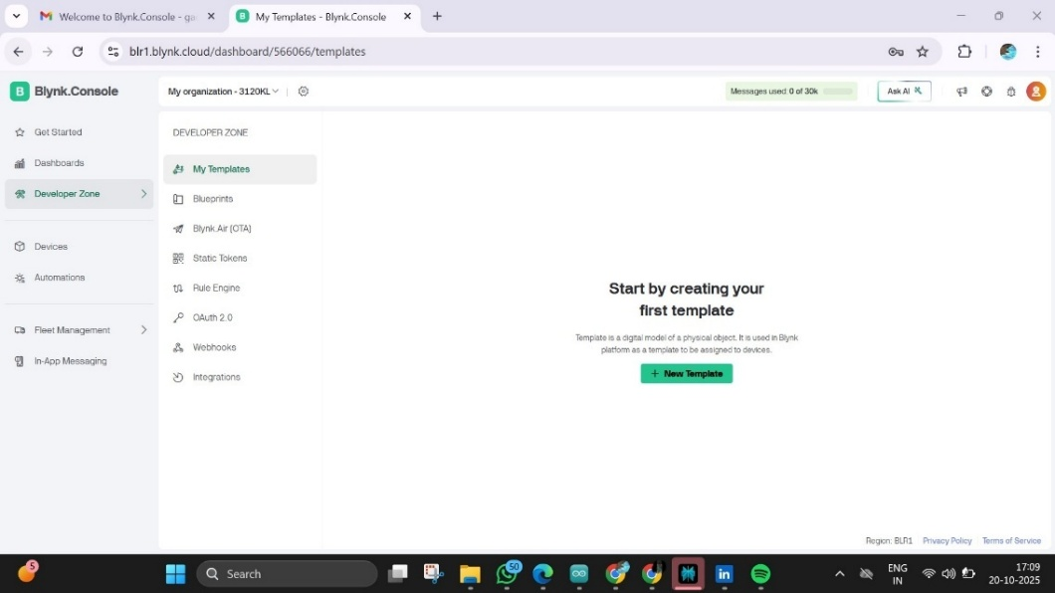
Fig., 10
Step 2: Create a New Template
- Click “+ New Template” (or Create New Template).
- Enter the following details:
  - Template Name: Voltage Monitor
  - Hardware: ESP32
  - Connection Type: Wi-Fi
- Click Create to save.
- The template’s Home page will open, showing configuration options.
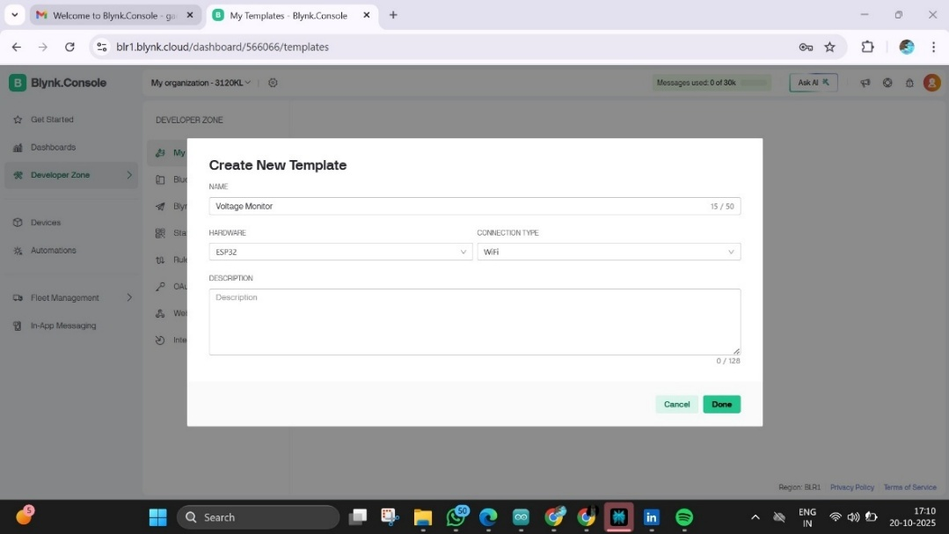
Fig., 11
Step 3: Go to Devices
- Now, in the left sidebar, click on “Devices.”
- Click “+ New Device” → “From Template.”
- Choose the template you just made (“Voltage Monitor”).
- Name your device (e.g., “Voltage Reader”).
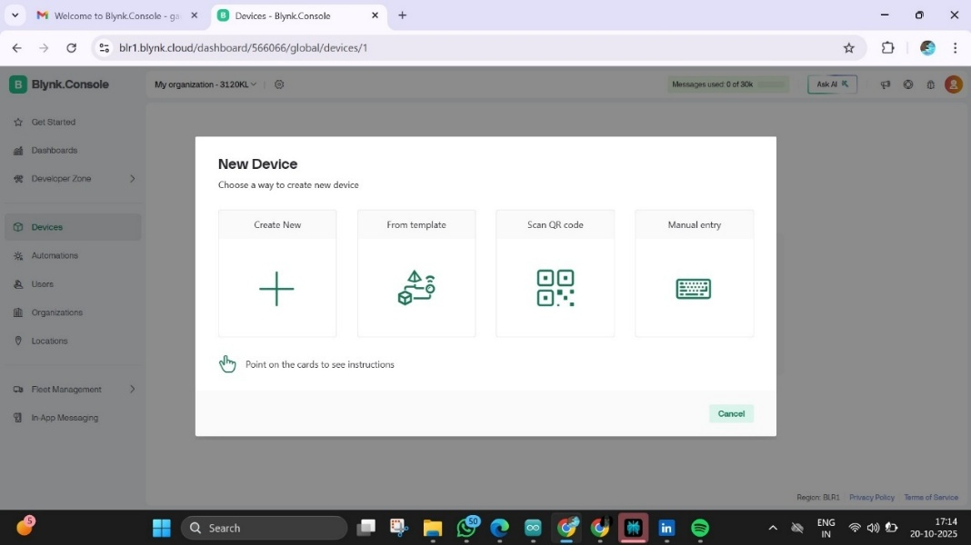
Fig., 12
Step 4: Copy Your Auth Token
- Click your device → go to Device Info (⚙️ icon).
- You’ll find the Auth Token field.
- Click Copy Token.

You will see three important parameters generated automatically:
#define BLYNK_TEMPLATE_ID "TMPL3_JhBwV9j"
#define BLYNK_TEMPLATE_NAME "Voltage Monitor"
#define BLYNK_AUTH_TOKEN "Sy9NSEbN4hBjqQn26ZCONcWqEFrOEG-G"
Copy these lines and paste them at the top of your Arduino code, replacing any previous template details.
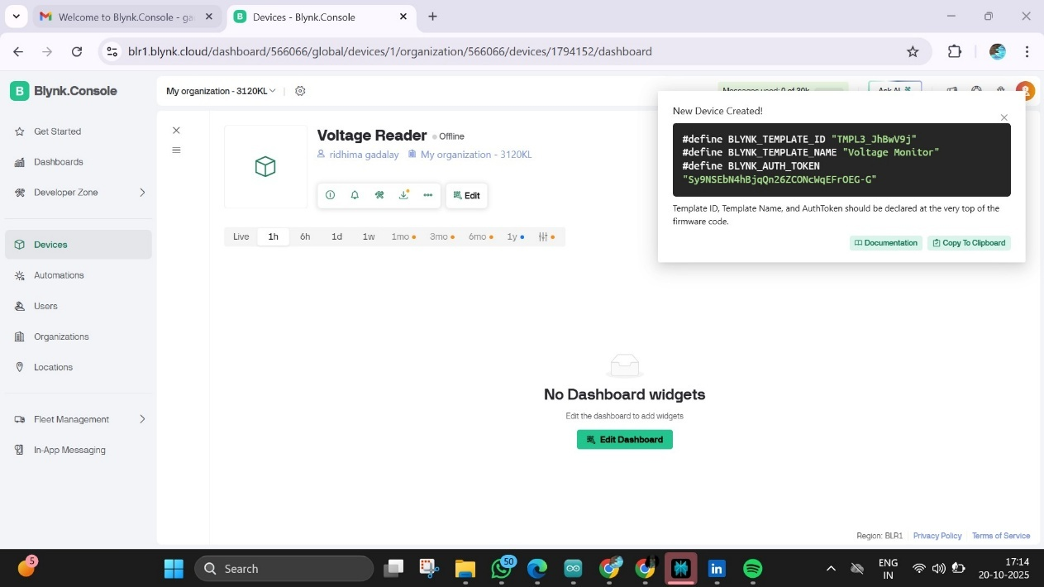
Fig., 13
Step 5: Configure Datastreams
- In the left panel, click Datastreams → Add Datastream → Virtual Pin.
- Create two datastreams for the voltage sensors:
  - V1 → Piezoelectric Tile Voltage
  - V2 → Hand Crank Voltage
- Select Data Type: Double
- Set Units: Volts (V)
- Click Create after each datastream.
Step 6: Set Up Web Dashboard
- Navigate to Web Dashboard from the left menu.
- Drag widgets such as Gauge, Value Display, or Chart onto the canvas.
- Assign each widget to its respective datastream (V1 or V2).
- Click Save in the upper-right corner.
Step 7: Upload and Connect
- Paste the copied template lines and Auth Token at the top of your Arduino sketch.
- Verify that your Wi-Fi SSID and Password in the code are correct.
- Set the baud rate in both your code and Serial Monitor (commonly 9600 or 115200).
- Upload the code to your ESP32 using the Arduino IDE.
- Once uploaded, open the Serial Monitor to confirm successful connection to Wi-Fi and the Blynk Cloud.
Step 8: Monitor Data
- Open the Blynk Web Dashboard or the Blynk Mobile App.
- You will see real-time voltage readings displayed for:
  - V1 — Piezoelectric voltage output
  - V2 — Hand crank generator output
These values are transmitted from the ESP32 to the Blynk Cloud, allowing wireless monitoring of energy generation data.

1.6 Blynk Mobile App Setup
Objective
The Blynk mobile application is used to remotely monitor the voltage values generated by the piezoelectric tiles and hand-crank system. It connects directly to the Blynk Cloud using the ESP32’s Wi-Fi connection.
Step 1: Install the App
- Download the Blynk IoT app from:
  - Google Play Store (for Android) or
  - Apple App Store (for iOS).
Step 2: Log In
- Open the app and sign in using the same email ID and password you used for the Blynk web console.
Step 3: Add a New Template
- Tap the “+” (Plus) icon or “Add New Template”.
- Select Use from Template and choose Voltage Monitor (the one created earlier on the web).
- The app automatically imports the same datastreams (V1 and V2) linked to your project.

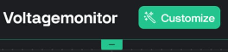
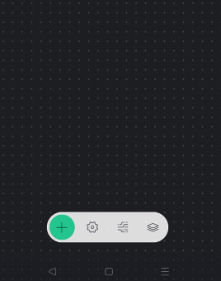
Fig., 14
Step 4: Add Widgets
- Tap the “+” icon to open the widget list.
- Add widgets such as:
  - Gauge or Value Display for Voltage 1 (V1).
  - Gauge or Value Display for Voltage 2 (V2).
- Link each widget to its respective Virtual Pin (V1 or V2).
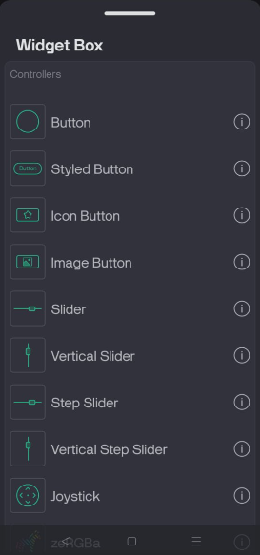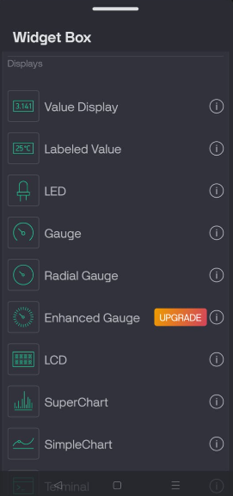
Fig., 15
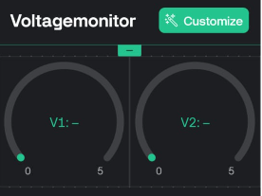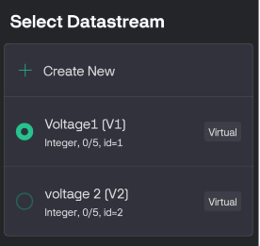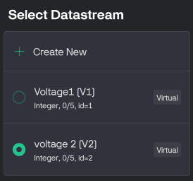
Fig., 16
Step 5: Connect the Device
- Ensure your ESP32 is powered and connected to Wi-Fi.
- The app will automatically show the device status as “Online” once it connects to the Blynk Cloud.
- If it remains “Offline,” check your Wi-Fi credentials or re-upload the Arduino code with the correct Auth Token.
Step 6: Monitor Live Data
- When the piezo tile or hand crank generates voltage, the app instantly displays:
  - V1 → Piezoelectric Tile Output
  - V2 → Hand Crank Output
- The readings update in real-time, providing live monitoring of the harvested energy.
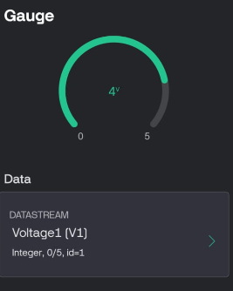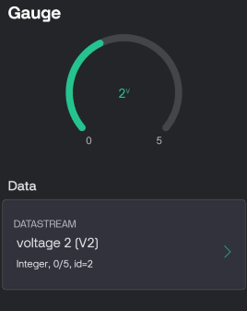
Fig., 17
Conclusion
The Blynk setup integrates hardware and software seamlessly, providing both local display (via LCD) and remote monitoring (via Blynk Cloud). By following the above steps, the ESP32 successfully communicates voltage readings wirelessly, enhancing the system’s interactivity and user awareness of generated renewable energy.

